NRS Primary School
CODE OF CONDUCT



Republiekstraat 150
Privaatsak X9317
Vryheid 3100
Telefoon (034) 9814800/9814809 (Skool)

Faks: (034) 9814071
E-Pos: nrs@lantic.net
Webblad: nrsprimary.co.za
EMIS: 241240

150 Republiek Street
Private Bag X9317
Vryheid 3100
Telephone (034) 9814800/9814809 (School)

Fax: (034) 9814071
E-Mail: nrs@lantic.net
Website: nrsprimary.co.za
EMIS: 241240

Table of Contents

Introduction 1
Part 1: School Rules 3
- General Principles 4
- School and Class Attendance 4
- School Uniform and General Appearance 5
- Valuable and Personal Belongings 5
- General Rules 6
- Rules Governing Public Places 7
- Transport 7
- School Enrichment Programme 8
- Accommodation of Religious or Cultural Rights 8
Part 2: Disciplinary System 11
- Grading of Offences 12
- Disciplinary Procedures 12
  - Grade 1 Offences 12
  - Grade 2 Offences 13
  - Grade 3 Offences 13
  - Grade 4 Offences 14
- Disciplinary Procedures 14
- Suspension of a Learner by the Principal or Deputy Principal as a Precautionary Measure 15
- Disciplinary and Tribunal Hearings 16
- Procedure during Hearings 17
Annexures 19
Annexure A: Learner Commitment 20
Annexure B 21
- Table 1: List of offences per grade of offence 21
- Table 2: List of the possible disciplinary sanctions to be applied
for Grade 1, 2, 3 and 4 offences, respectively 24
Annexure C: Written Warning 29
Annexure D: Final Written Warning 30
Annexure E: Notice of Disciplinary Hearing 31
Annexure F: Record of Disciplinary Hearing 33
Annexure G: Lodging of Appeal (Review Form) 34

Introduction
This School is committed to providing an environment for the delivery of quality teaching and learning by:

: Promoting the rights and safety of all learners and teachers and parents.
Ensuring learners’ responsibility for their own actions and behaviours.
Prohibiting all forms of unfair discrimination and intolerance.
Eliminating disruptive and offensive conduct.

The Code of Conduct spells out the rules regarding learner behavior at the School and describes the disciplinary system to be implemented by the School concerning transgressions by learners. The Code of Conduct applies to all learners while they are on the School premises or when they are away from the School representing it or attending a School function.

Section 8(4) of the SA Schools Act provides that all learners attending a School are bound by the Code of Conduct of that School. All learners attending the School are expected to sign a statement of commitment to the Code of Conduct (Annexure A). The administration of the Code of Conduct is the responsibility of the Disciplinary Committee of the School.

code of conduct

Part 1: School Rules


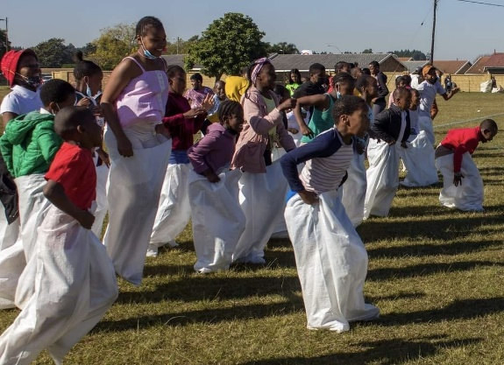


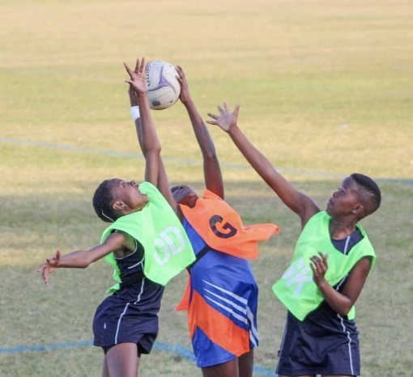
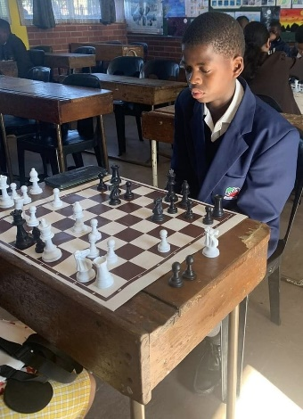
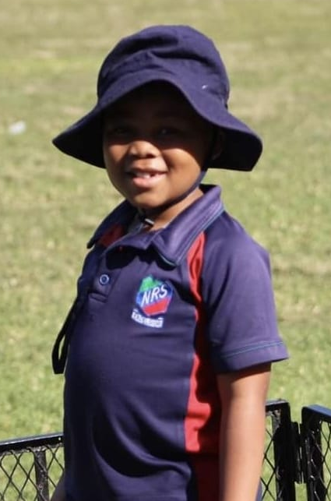

General Principles

School and Class Attendance

School Uniform and General Appearance

- Valuables and Personal Belongings

General Rules

Rules Governing Public Places

Transport

School Enrichment Programme

Accommodation of Religious or Cultural Rights

1 Part 1: School Rules
The School rules are intended to establish a disciplined and purposeful environment to facilitate effective teaching and learning at the School. Nothing shall exempt a learner from complying with the School rules. Ignorance of School rules is, therefore, not an acceptable excuse.

General Principles

    - Learners are expected at all times to behave in a courteous and considerate manner towards each other, the Representative Council of Learners (RCL), all members of staff and visitors to the School.
    - Learners are expected to abide by the School rules with regard to appearance and behavior when representing the School both during School hours and after School hours, at School and away from School. Learners may not say or do anything that will discredit themselves or the School.
    - No learner has the right at any time to behave in a manner that will disrupt the learning activity of other learners, or will cause another learner physical or emotional harm.
    - The School will contact parents/guardians when a learner’s behavior becomes a cause of concern and will endeavor, in a spirit of constructive partnership, to resolve the problem.

School and Class Attendance

Parents/guardians, learners, teachers and School Governing Body (SGB) members are jointly responsible for ensuring that all learners attend School.

    - If a learner does not attend School regularly, the relevant register teacher will report the absence of the learner to the parent and the Principal in writing. The register teacher must keep an accurate register of learner attendance and must keep copies of all communication to parents when absence from the classroom is reported.
    - All learners are to arrive at School before the official starting time. Learners who are late for School will be marked absent as registers are completed at the beginning of each School day.
    - Absence from a class, without the permission of the relevant register or subject teacher, is prohibited.

    - Any absence from School must be covered by an absentee note from a parent/guardian.
    - Should a learner be absent from School for a period of three (3) days or longer, this leave of absence must be supported by a letter from a medical doctor/traditional doctor/registered herbalist.
    - Any absence from a formal examination, test or task must be supported by a letter from a medical doctor/traditional doctor/registered herbalist.
    - No learner may leave the School during School hours without a letter from a parent/guardian requesting the release of their child and the permission of the Principal/Deputy Principal/Grade Head from whom an exit note must be obtained.
    - Truancy from School is prohibited.
    - All learners will attend assembly for the full duration thereof.

School Uniform and General Appearance

Learners are expected to wear the official School uniform and appear neat and tidy at all times.

  - No additions to the uniform that are not in accordance with the regulations will be allowed
  - No, jewelry, accessories, colored contact lenses or visible tattoos are allowed. Only earrings that are golden or silver studs/rings, no rhinestones.
  - No coloring of hair or wearing of exotic hairstyles is allowed.
  - Fingernails must be kept trimmed short and clean at all times. No Nail polish/paint.
  - During events that allow the wearing of casual wear, learners should wear neat, presentable clothes. Beachwear, tight-fitting clothes, clothes that are see- through and/or too revealing are not allowed. Hair, shoes and accessories should be neat at all times. Appropriate underwear is compulsory.
  - Only learners that have applied, submitted relevant supporting documents and received the necessary permission from the School Governing Body, may deviate from official School uniform for religious and cultural reasons as contemplated in Part 1 paragraph I of this Code of Conduct.

Valuables and Personal Belongings

The School will not be held responsible for theft of or damage to personal belongings on School premises (e.g. cell phones, bags, books and clothing).

  - Learners should avoid bringing cell phones, large sums of money and

valuables to School. Cell phones/game consoles, and/or similar technology are strictly NOT allowed. If the learner brings a cell phone to School, the learner must carry a written request from the parent, which must provide for an indenification against loss of or damage to the cell phone, and the cell phone(s) are to be handed in at the adimin office before school and will be handed back when the learner leaves.
  - If a parent requests a learner to pay School fees on his/her behalf, such School fees should be paid before the start of the School day.
  - Arrangements should be made with the teacher in charge for safekeeping of valuables, etc. during sports practices.
  - Learners may NOT bring cellphones, computers/consoles and or computer/console games, iPods or similar electronic devices to School.

General Rules

  - Loitering and/or playing in and around the corridors, stairwells and toilets is forbidden.
  - All litter must be placed in refuse bins or wastepaper baskets.
  - Willful damaging, vandalizing or neglect of School property and the property of others, either by writing or by a physical act, is prohibited. Theft of School and private property is also prohibited.
  - Any act of cheating in class work, homework, informal and formal tests or internal or external examination is prohibited. Furthermore, copying of and/or borrowing another learner’s work is forbidden.
  - Disruptive, unruly, rude and/or offensive behavior will not be tolerated.
  - The timeous handing in of work is the responsibility of each learner.
  - Learners who fail to produce a medical certificate on absenteeism during formal examinations/tests/assessment tasks will obtain a mark of “0” (naught) for the particular examination/test/assessment task.
  - The learner will respect the beliefs, culture, dignity and rights of other learners, as well as their right to privacy and confidentiality.
  - Language that is seen as pejorative, discriminatory or racist is prohibited.
  - Any act that belittles, demeans or humiliates another learner’s culture, race or religion is prohibited.
  - All learners have the right to an education free of interference, intimidation and/or physical abuse. The learner will respect the property and safety of other learners. Fighting or threatening of other learners is forbidden.
  - The learner will respect those learners in positions of authority. A learner who is in a position of authority will conduct him/herself in a manner befitting someone in authority. S/he will respect the rights of other learners and will not abuse such authority bestowed upon him/her through his/her position.
  - The carrying, copying and/or reading of offensive material is prohibited.

  - Learners must keep clear of areas that are indicated as out of bounds. These include:

    - The School motor vehicles garage.
    - The playing fields,swimming pool and area, except while attending official sports practice and matches or during a lesson while under the supervision of the subject teacher.
    - Electrical mains distribution boxes, fire extinguishers and hoses.
    - Parking lots.

Rules Governing Public Places

The School is a place of safety where laws pertaining to public spaces are applicable.

  - No dangerous objects or illegal drugs as defined in the SA Schools Act or the Safety Regulations will be brought onto and/or used on the School property unless authorized by the Principal for educational purposes. Dangerous objects include knives, firearms or any item that could harm a person.
  - The carrying and/or smoking of cigarettes is prohibited.
  - Alcohol is not permitted on School premises or during any School activity.
  - The carrying of and/or consumption of illegal chemical substances and drugs is prohibited.

Transport

  - The Code of Conduct is applicable when making use of public transport to and from School.
  - Learners may not hitchhike while in School uniform, whether formal or sports dress.
  - No learners to be transported on the back of a vehicle to the sport fields.

School Enrichment Program

Involvement in activities making up the School Enrichment Program forms a valuable and integral part of the holistic education of every learner. All learners are, therefore, expected to become actively involved in at least one (1) sport/ cultural activity per term.

  - The learner is expected to adopt the correct etiquette pertaining to the specific activity at all times.
  - Once a learner has committed him/herself to an activity, s/he will be bound to meet the rules and obligations related to that activity.
  - Involvement in a particular activity will span the entire season/duration in which that activity takes place.
  - Attendance of all practices is compulsory. Missing a practice without a valid excuse in writing from the learner’s parents may result in the learner being suspended from participation in one (1) inter-school league fixture.
  - Appropriate kit/uniform will be worn to practices.
  - The correct match kit/uniform will be worn to inter-school league fixtures.
  - Learners travelling to an away fixture will travel in full School uniform, unless other arrangements have been made.
  - Sports and other kit must be carried in an appropriate bag.
  - Learners playing in home league fixtures may arrive at the venue in their appropriate sports kit/uniform.

Accommodation of Religious or Cultural Rights

Religious practices, conduct or obligations that relate to the core values and beliefs of a recognized religion and that are in conflict with any rule contained in this Code of Conduct will be accommodated by a deviation from this Code of Conduct by the Governing Body under the following conditions:

  - The learner, assisted by the parent, must apply for a deviation from the standard School rules if such rules are in conflict with or infringe on any religious right of the learner.
  - This application must be in writing and must identify the specific rule/s that is/are offensive to the learner’s religious right/s as contained in the Constitution of the Republic of South Africa.

  - This application must include a reasonable interpretation of the religious rights that the learner feels are offended and a suggestion on how the rules may be supplemented by the Governing Body to accommodate such religious rights.
  - The learner must provide proof that s/he belongs to that specific religion and that the religious practices, rules and obligations that are in conflict with the School’s Code of Conduct are his/her true beliefs and commitments.
  - The religious conduct or practice must be lawful.
  - The Governing Body must consider the application and, if it is satisfied that the application is justified in terms of Constitutional principles, the application will be granted in writing.
  - When the Governing Body allows for deviations from the standard rules, such deviations must be based on core religious beliefs inherent to the religion, and it must be compulsory for the learner to comply with such beliefs.
  - The deviation must specify the extent of the exemption from the normal rules and must clearly identify the conduct that will be allowed – e.g. the wearing of a head scarf, including colors and details of design; the growing of a beard; or the wearing of a specific hairstyle or jeweler – and the conditions under which such deviation will be applicable to the learner.
  - Cultural rights will be considered in the event that they do not relate to a religion, if such cultural rights manifest in conduct of a permanent nature that is compulsory for the cultural group. This refers to cases where the removal of the cultural jeweler or mark will cause considerable pain to the learner. Normally, cultural rights are exercised through marks and expressions of a temporary nature that are justified for a specific cultural gathering. The learner must convince the Governing Body that his/her cultural rights can be exercised only through a permanent intervention.
  - Any request for a deviation from the Code of Conduct based on cultural rights must be in writing and must be based on a process similar to that contained in subparagraphs 1 to 8 above.

code of conduct

Part 2: Disciplinary System
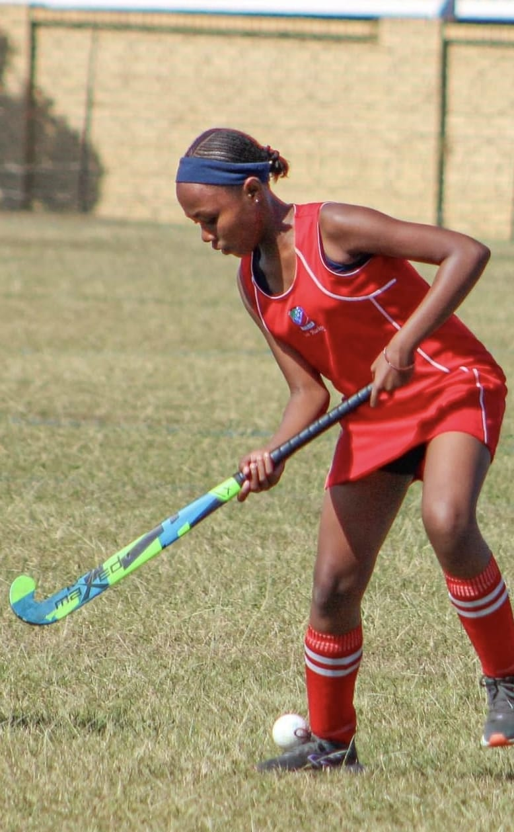
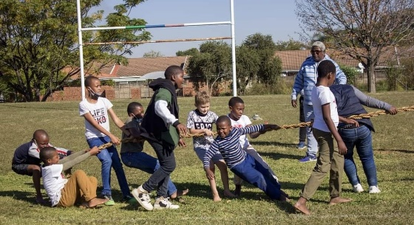



Grading of Offences

Disciplinary Procedures

- Disciplinary Interventions

- Suspension of a Learner by the Principal or Deputy Principal as a Precautionary Measure

- Disciplinary and Tribunal Hearings

- Procedure during Hearings

2Part 2: Disciplinary System
Every teacher is responsible for discipline and has the full authority and responsibility to correct the behavior of learners whenever such correction is necessary. Any corrective measure or disciplinary action will correspond with and be appropriate to the offence.

All learners will abide by the discipline system that has been developed to assist and guide learner behavior in the School.

Grading of Offences

Offences are graded according to the nature and degree of seriousness of the offences, of which Grade 4 offences are the most serious. See Annexure B, Table 1 for a list of the offences making up each of the Grades 1, 2, 3 and 4.

Disciplinary Procedures

The grade of an offence will determine the procedure to be followed.

    - Grade 1 offence – a written warning followed by a final written warning, then a disciplinary hearing.
    - Grade 2 offence – a final written warning followed by a disciplinary hearing, then a tribunal hearing.
    - Grade 3 offence – a disciplinary hearing or a tribunal hearing (depending on the severity of the particular offence).
    - Grade 4 offence – offence immediately reported to the South African Police Service (SAPS) and a tribunal hearing.

Grade 1: Offences
All Grade 1 offences will be dealt with by the staff member concerned who must keep a written record of such offences and the disciplinary measure taken.

When a third Grade 1 offence occurs, the matter is referred to the Grade Head along with the record of all three (3) offences and the Grade Head will issue a written warning. A signed copy of acknowledgement will be kept on record by the Grade Head and communicated to the parent/guardian.

Should the particular Grade 1 offence recur after disciplinary intervention has occurred and a written warning has been issued, the staff member will, in consultation with the Grade Head, arrange an interview with the learner. A final written warning will be issued. A signed copy of acknowledgement will be kept on record by the Grade Head and communicated to the parent/guardian.

The Grade Head will keep on record copies of all relevant documentation relating to the offences and the disciplinary measures imposed and provide copies thereof to the learner’s register teacher.

Grade 2: Offences

Grade 3: Offences
All Grade 2 offences will immediately be referred to the Grade Head. The staff member will, in consultation with the Grade Head, arrange an interview with the learner. A final written warning will be issued and disciplinary action applied. A signed copy of acknowledgement will be kept on record by the Grade Head and communicated to the parent/guardian.

When a second Grade 2 offence occurs after a final written warning has been issued for the first offence, the Grade Head will refer the matter to the Disciplinary Committee for a disciplinary hearing. The parent/guardian will be advised in writing, a minimum of five (5) days before the designated date, that an internal disciplinary hearing has been convened.

Should the particular Grade 2 offence recur after the issuing of a final written warning and a disciplinary hearing has occurred, the Disciplinary Committee will refer the matter to a tribunal hearing. The parent/guardian will be advised in writing, a minimum of five (5) days before the designated date that a tribunal hearing has been convened.

The Grade Head will keep on record copies of all relevant documentation relating to the offences and the disciplinary measures imposed and provide copies thereof to the learner’s register teacher.

All Grade 3 offences will immediately be reported to the Grade Head. The Grade Head will refer the matter to the Disciplinary Committee who will, depending on the severity of the offence, determine whether to convene a disciplinary hearing or a tribunal hearing. The parent/guardian will be advised in writing, a minimum of five (5) days before the designated date that a hearing has been convened.

Grade 4: Offences
All Grade 4 offences will immediately be reported to the Grade Head. The Grade Head will refer the matter to the School Principal who will immediately file a report with the SAPS and convene a tribunal hearing. The parent/guardian will be informed immediately of the offence and be advised in writing, a minimum of five
(5) days before the designated date that a hearing has been convened.

Disciplinary Interventions

    - The following list of interventions and corrective measures used by the School are aimed at correcting behavior before suspension and expulsion:

      - A verbal warning/reprimand to express disapproval.
      - Written warning.
      - Final written warning.
      - Removal from classes.
      - Written punishment.
      - Community service to improve the physical environment within and around the School property.
      - Supervised schoolwork.
      - De-merit detention points on Principal Plus
      - Referral for counselling.
      - Attendance of a relevant life skills programmer.
      - Fines to compensate for damages, to cover the cost of repair or replacement of the lost or damaged item, and/or the accumulated fine.
      - Temporary suspension of library card and/or other School-related privileges
      - Exclusion from School activities and functions, e.g. academic award ceremony.
      - Withdrawal of recognition, e.g. award.
      - Temporary suspension from class or School, pending disciplinary hearing.
      - Disciplinary hearing.
      - Tribunal hearing.

    - Failure to comply with interventions and corrective measures will lead to further interventions and may lead to the offence being categorized at a higher grade. Expulsion may be recommended for a Grade 3 and a Grade 4 offence. See Annexure B, Table 2 for a list of the possible disciplinary measures to be applied for Grade 1, 2, 3 and 4 offences respectively.

    - Conduct that may lead to suspension/exclusion includes, but is not limited to, the following:

      - Conduct that violates the rights or safety of others.
      - Criminal behavior of any kind.
      - Defacing or destroying School property.
      - Disrespectful or objectionable conduct and verbal abuse directed at teachers, other School employees or fellow learners.
      - Outright defiance of lawful requests or instructions issued by persons in authority.
      - Indulging in harmful graffiti, racism or “hate speech”.
      - Sexual harassment or sexual assault.
      - Immoral behavior or profanity.
      - Possessing, using or displaying evidence of use of any narcotics, unauthorized drugs, alcohol or any other intoxicant.
      - Repeated infringements of the School rules or the Code of Conduct.
      - Possession of dangerous weapons (guns, knives and other objects which may threaten the lives of learners/teachers).

    - Should a learner be found guilty by a court of law for breaking the law of the Republic of South Africa, the School has the right, after a fair hearing through the Governing Body, to recommend expulsion to the Provincial Department of Education.
    - A tribunal hearing will be convened with a view to recommending expulsion. In such instances the recommendation for expulsion will be submitted to the Provincial Head of Education to approve the decision.
    - Where approval for expulsion is not granted, learners will attend counselling or the relevant life skills programme before they may return to class. Such learners will be accommodated in the exclusion room in the interim to continue with schoolwork until they have completed the series of counselling sessions or the stipulated life skills programme.

Suspension of a Learner by the Principal or Deputy Principal as a Pre- cautionary Measure

The Governing Body authorizes the Principal or Deputy Principals to institute suspension, as a precautionary measure, with regard to a learner who is charged with a serious misconduct offence as contemplated in section 8 of the SA Schools Act.

    - Before a learner is suspended, the learner and his/her parents must be given an opportunity to indicate why the suspension should not be considered.
    - The disciplinary proceedings must commence within one (1) week after the suspension. If the proceedings do not commence within one (1) week, approval for the continuation of the suspension must be obtained from the Head of Department.
    - This suspension will be applicable until a finding of not guilty is made or, in the case of a finding of guilty, until the appropriate sanction is announced.

Disciplinary and Tribunal Hearings

    - The following official forms will be used for misconduct and disciplinary hearings:

  - Written warning (disciplinary warning form) (Annexure C)
  - Final written warning (Annexure D)
  - Notice of disciplinary hearing (Annexure E)
  - Record of disciplinary hearing (Annexure F)
  - Review form (lodging of appeal) (Annexure G)

    - Written notice of a disciplinary or tribunal hearing will be given at least five (5) School days before the hearing, which could imply temporary suspension from classes, excluding formal scheduled tests and examinations which count towards the year mark.
    - When a notice is issued to a learner the learner must acknowledge receipt of notice by signing for it. This is not an admission of guilt.
    - If a learner does not appear at a hearing, the hearing will be conducted in his/her absence.
    - A written verdict of the hearing will be issued to the offender. The offender must acknowledge the content by signing the document.
    - A learner has the right to request a review of the disciplinary action taken against him/her if sufficient grounds exist. Disregard of punishment of the Disciplinary Committee will lead to temporary suspension pending a hearing.
    - The Disciplinary Hearing Commission will consist of the following members:

  - a Governing Body representative;
  - the School Principal or Discipline Officer delegated to oversee this function;
  - the Grade Head; and
  - the register teacher.

    - The hearing will also be attended by the learner, and any other learner s/he may need for his/her defense.
    - Disciplinary measures that a Disciplinary Hearing Committee may impose include:

  - Demerits.
  - Suspension from School for a minimum of two days up to a maximum of five (5) days, ratified by the Governing Body, to be effective immediately. This will be put in writing and a copy kept on record.
  - Recommendation with respect to counselling/attendance of a life skills programme.
  - Progress monitoring process initiated for a minimum of two (2) weeks, followed up with a progress report.
  - A written conduct and behavior warning issued. A signed copy of acknowledgement will be kept on record.
  - Payment to cover the cost of repair or replacement of the damaged, lost or stolen item.

    - The Tribunal Hearing Commission will consist of the following members:

  - the Governing Body Chairperson;
  - two (2) parent representatives from the Governing Body;
  - the School Principal or Discipline Officer delegated to oversee this function; and
  - the Grade Head.

    - The Principal/Discipline Officer will keep on record copies of all documentation relating to the offence, the conducting and findings of the hearing, and the disciplinary measures imposed.
    - The Principal/Discipline Officer will furnish the relevant Grade Head and register teacher with all the information necessary for their records.

Procedure during Hearings

    - The Chairperson of the Committee must lead the proceedings and:

      - Introduce those present and state their functions.
      - Ensure that witnesses are present only while giving their evidence.

    - The Chairperson must inform the learner of his/her rights:

      - The right to a formal hearing.
      - The right to be present at the hearing.
      - The right to be given time to prepare for the hearing case.
      - The right to be given advance notice of the charges.
      - The right to be represented at the hearing by one (1) internal representative.
      - The right to be accompanied at the hearing by parents/guardian if the learner is a minor.
      - The right to ask questions on any evidence produced, or on statements of witnesses.
      - The right to call witnesses to testify on his/her behalf.
      - The right to an interpreter, to be requested 24 hours prior to the hearing.
      - The right to appeal within five (5) days against any penalty imposed by the Disciplinary Committee.
      - If the learner does not attend, the hearing will be conducted in his/her absence.

    - The Chairperson is to explain the nature of the alleged breach or misconduct to those present at the hearing.
    - The procedure of enquiry is to be explained by The Chairperson. The evidence of the complainant and his/her witnesses will be heard first. The learner and panel may ask questions about the evidence. The learner and his/her witnesses may then give evidence and the complainant and Committee may ask them questions.
    - When all the evidence has been heard, The Chairperson must close the enquiry, dismiss the complainant, the accused, their representatives, the parent/guardian and all the witnesses.
    - The Disciplinary Committee must discuss and weigh the evidence and come to a decision.
    - The Chairperson must reconvene all interested parties.
    - The Chairperson is to communicate the decision of The Committee.
    - The Chairperson must explain the decision of The Committee and the reasons for the penalty (if any) that has been imposed.
    - The learner must be advised of his right to appeal (Annexure E).
    - The complainant and learner must sign the disciplinary form and a copy must be handed to the learner. (If the learner refuses, a witness must sign in the presence of the learner).
    - The signing of the document by the learner does not imply an acknowledgement of guilt.

Annexures
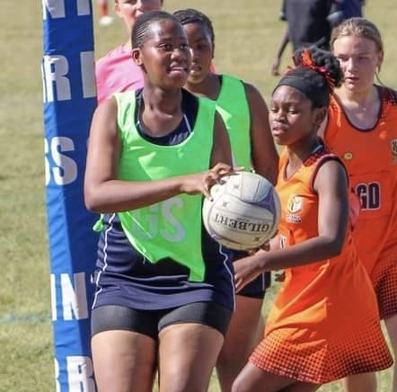




Annexure A: Learner Commitment

Annexure B: Table 1: List of offences per grade of offence
Table 2: List of the possible disciplinary sanctions to be applied for Grade 1, 2, 3 and 4 offences, respectively

Annexure C: Written Warning Annexure D: Final Written Warning

Annexure E: Notice of Disciplinary Hearing
Rights of Learner facing Disciplinary Action Annexure F: Record of Disciplinary Hearing

Annexure G: Lodging of Appeal (Review form)

AAnnexure A

Learner Commitment
- Abide by the Code of Conduct and Disciplinary System.
- Behave in a courteous and considerate manner and respect other learners, the LRC, all members of staff and visitors to the School.
- Treat everyone with respect regardless of differences in culture, religion, ability, race, gender, age, sexual orientation or social class.
- Take responsibility for my learning by attending regularly and punctually and completing all my assessment tasks on time.
- Cooperate with my teachers and other School staff.
- Assist in making the School a safe place for all.
- Seek help if I need it.
- Let the School know if I feel my rights have been infringed, or if I experience any other difficulty.
School: NUWE REPUBLIEK SCHOOL
I, ……………………………………………………., a learner at …………………………. School, understand the rules and
their implications and hereby commit to:
..........................................................
Learner
...........................................................
Parent/Guardian
..........................................................
Date

BAnnexure B

Table 1: List of offences per grade of offence
Grade 1: Offences | Grade 2: Offences | Grade 3: Offences | Grade 4: Offences
- littering  - excessively noisy or unruly behavior before School, during change-overs, during breaks, and after School  - eating, drinking or chewing gum during any contact time (class and assembly)  - misconduct in an assembly  - entering an out of bounds area, classroom or passage without permission  - loitering in the passages, at the tuck shop or vending machines, at the toilets or change rooms  - misconduct or poor sportsmanship during an extra-mural activity’s practice, intra- or inter-School competition or league fixture  - failure to:  - submit an absentee note or exit notes by the stipulated deadlines  - return a library book by the due date, or | - vandalism  - interfering with another person’s possessions/ property without the owner’s consent  - damaging another person’s possessions/ property as a result of interfering or using said possession or property without the owner’s consent  - racism: remarks/ insults  - forgery: altering of official documents such as medical certificates and qualifications and fraudulent use thereof  - intimidation by verbal or physical threat to harm the person or his property (bullying)  - swearing, lying or using obscene gestures  - verbal or non-verbal abuse  - disrespect or insolence  - insubordination – ignoring or failing to carry out a specific instruction (to include failure to do work/ punishment set in the exclusion room, or | - possession of weapons that can cause physical injury (knives, etc.)  - entering the School premises while under the influence of alcohol/drugs  - Vaping/using.  - possession, copying, distribution, use or displaying of porno- graphic material  - assault with the intent to do grievous bodily harm  - truancy from School or leaving School grounds without the necessary permission  - taking part in any form of illegal strike action/ meeting/campaign on School premises  - any learner who, in or outside of the buildings, or on or off the premises of the School, whilst under the control of the School authorities, intentionally conducts himself in a manner which is or could be seriously detrimental to the maintenance of order or discipline at the School | - use of weapons that cause physical injury (knives, etc.)  - possession and/or use of a firearm, firearm magazine, ammunition, dangerous or lethal weapon  - possession, using and/or dealing in drugs, or alcohol, or any other intoxicating substance  - poisoning, or attempt- ting to poison another person  - theft, robbery, breaking and entering  - malicious damage/ injury to property of the School, staff members, fellow learners or any other person or body  - rape, attempted rape, or indecent assault  - physical assault that results in bodily harm  - sedition or inciting any form of illegal strike action/meeting/ campaign on School premises  - Any offence punishable under common law

NRS Code of Conduct 21

Table 1: List of offences per grade of offence (continued)
Grade 1: Offences | Grade 2: Offences | Grade 3: Offences | Grade 4: Offences
pay the fine for overdue book/s  - attend an extra- mural activity’s practice session without excusing himself  - attend duty class  - attend a compulsory activity as a spectator without submitting a written excuse letter prior to the event  - attend detention  - continual interference with another learner which causes minor physical or mental discomfort  - misconduct during detention  - minor infringements of uniform regulations: wearing of printed T- shirts; an incorrect jersey or tracksuit top as an outer garment; incorrect color socks or belt; wearing of jewelry  - failure to wear the correct full School uniform when in a public place, including the wearing of unauthorized items  - failure to wear the correct sports kit for a match or practice | failure to report to the exclusion room, or failure to report to the subject teacher with this work/punishment as stipulated)  - Sexual converstions | Books | Material.  - fighting, common assault or attempted assault  - public disturbance and public indecency  - gambling  - unacceptable hair styles, including bleaching or coloring  - display of visible tattoos  - using a cell phone as a means of communication during formal testing  - cheating, attempting to cheat, or having forbidden material or information in a test venue during controlled testing (class tests, term tests, internal exams). This includes any form of communication, verbal or non-verbal, with another learner  - copying of computer exercises, projects or any other work | - violating the rights of other learners to receive education by disrupting classes, preventing other learners from attending classes, preventing teachers from providing teaching, or in any other manner  - violating the rights of the teacher to carry out his/her tasks, to the detriment of the School, the staff, the teacher, or fellow learners  - unreasonable repetition of a Grade 2 offence  - Sexual harassment towards anyone, Teacher or learner.

Table 1: List of offences per grade of offence (continued)
Grade 1: Offences | Grade 2: Offences | Grade 3: Offences | Grade 4: Offences
- hitchhiking while in School uniform, formal or sport dress  - disruptive behavior in class  - spitting in public  - failure to:  - do classwork set and submit homework  - bring the required textbooks, notes, stationery, or equipment to a lesson  - hand work in on time  - copying another learner’s classwork or homework  - defacing School property  - reporting late for class, relief, or to the exclusion room  - use of offensive material to cover books or files  - possession and/or use of a cell phone, computer game, iPod and similar electronic devices, during all contact time  - arriving late for School without an excuse note | intended for the year mark  - truancy from any contact time  - possession or use of fire crackers  - failure to attend an extra-mural activity fixture or function as a participant or official  - any action which brings the School’s name into disrepute  - possession of offensive material, excluding pornographic material  - tampering with safety and other equipment on School premises  - unreasonable repetition of a Grade 1 offence  - Sexual harrasment

NRS Code of Conduct. 23

Table 2: List of the possible disciplinary sanctions to be applied for Grade 1, 2, 3 and 4 offences, respectively

Each case must be evaluated on its own merits and must be provided with a sanction justified for that specific case. The recommended sanctions provided in this table are guidelines for the Disciplinary Committee.

Grade 1: Offences | Recommended Corrective Sanctions
- Academic: Books/work materials left at home; homework -not done on time/copied  - Extra-mutual activity: Non-attendance at practices and matches (without a valid excuse to teachers/ coach)  - Personal conduct in classroom/on playground: Inappropriate displays of affection between learners; late arrival for class; uncooperative behavior; discourteous behavior/insolence/temper tantrum; foul language; defacing desks/walls/books/cases with graffiti; eating/chewing in class; littering; and cell phone ringing  - Dress code: Untidiness/unkempt appearance;  School dress code not followed | Corrective actions/sanctions are carried out by the individual teacher and may include the following:  - Verbal reprimand;  - Written punishment;  - Detention at break;  - Temporary confiscation until the end of School term (e.g. uniform, jewelry, cell phones, bags and cases);  - Removing graffiti from bags and cases at break; and  - Written notification
Grade 2: Offences | Recommended Corrective Sanctions
1. Plagiarism of any work or cheating/attempted cheating in class test/assignment | Naught for test and warning letter
2. Damage to property/possession of other learners’ property | Repair/replacement, warning letter
3. Defiance/disregarding of an authority figure’s instructions | Suspension from class, warning letter
4. Disregarding test/examination procedures | Warning letter and Principal’s
5. Disruptive/uncooperative in class | Identification of culprit/s and grade teacher to organize corrective measures
6. Disruptive behavior frustrating teaching and learning in the classroom | Warning letter
7. Repeated dress code infringements (including hair and personal grooming) | After three (3) warnings, Principal’s detention

Table 2: List of the possible disciplinary sanctions to be applied for Grade 1, 2, 3 and 4 offences, respectively (continued)

Grade 2: Offences | Recommended Corrective Sanctions
9. Fighting | Warning letter
10. Fire-crackers | Warning letter
11. Forgery, e.g. parent/guardian’s signature | Warning letter
12. Gambling on or off School property | 1set offence: Written warning parent involvement  2nd offenceWritten warning parent involement  3rd offence: Information disciplinary hearing, spdetention and professional counselling  (All money to be confiscated)
13. Graffiti: books, case, desks, walls, etc. | Removal, warning letter
14. Late for School – three (3) days | Phone call to parents
15. Late arrival at School after 8:20 am | Phone call to parents
16. Lying | Warning letter
17. Offensive material | Warning letter
18. Smoking – possession of cigarette and or vape/holding cigarette and or vape/caught in the act on/off School property | 1st offence: Written Warning Phone parents  2nd offence: Written warning phone parents  3rd offence: Formal disciplinary hearing, specidetention and professional counselling  (All cigarettes and lighters to be confiscated)
19. Smoking – selling cigarettes/vapes/space muffins on/off School property | 1st offence: Information disciplinary hearing, warning letter  2nd offence: Formal disciplinary hearing, warning letter
20. Spitting | Written warning, Parent involvement
21. Sticking a sharp object, e.g. pin, pen, nib, etc. into a fellow learner | Warning letter
22. Substance abuse – possession/sniffing of unauthorized substance, e.g. meths, benzene, thinners, space muffins etc. | Information hearing, warning letter  Drug test with permision from parents
23. Threatening assault/intimidation of a fellow learner | Phone call to parents and warning letter
24. Truancy – bunking a day or part of a day | Phone call to parents, warning letter

Table 2: List of the possible disciplinary sanctions to be applied for Grade 1, 2, 3 and 4 offences, respectively (continued)

Grade 2: Offences | Recommended Corrective Sanctions
25. Vandalism – defacing/damaging/breaking School property | Phone call to parents, warning letter and replacement of property or financial contribution .
26. Verbal abuse of a fellow learner | Phone call to parents, repairs/payment of damages, warning letter.
Grade 3: Offences | Recommended Corrective Sanctions
1. Alcohol – possession at School or on a School outing/smelling of liquor/under the influence at School or on School outing | Disciplinary hearing, warning letter, community service.
2. Assault on a fellow learner (causing bodily harm) | Suspension from class/School. Disciplinary hearing, warning letter, community service.
3. Bullying/Intimidation | Warning letter and community service.
4. Cheating/attempted cheating in examination/cycle test/portfolio work | Naught and warning letter
5. Possession/distribution of test or examination material prior to test or examination being written | Disciplinary hearing, naught for test/examination, warning letter, community service/official provincprocedures for Grade 12
6. Ongoing disruptive behavior in classroom (frustrating School’s educational programme) | Suspension from class/School. Disciplinary hearing, warning letter, community service .
7. Disruptive behavior on School property or on School sponsored fixture/outing/trip/tour (frustrating School’s educational/extracurricular programmer) | Suspension from class/School. Disciplinary hearing, warning letter, community service.
8. Engaging in a conspiracy to disrupt the proper functioning of School through collective action | Suspension from class/School. Disciplinary hearing, warning letter, community service.
9. Drugs – consumption not associated with School | Interview with parents, professional intervention
10. Gangs – promoting formation forming of/associating with/furthering activities of School gangs/‘social groups’ | Suspension from School. Disciplinary hearing, warning letter.
11. Involving/attempting to involve outsiders in disputes between learners | Disciplinary hearing, warning letter, community service.

Table 2: List of the possible disciplinary sanctions to be applied for Grade 1, 2, 3 and 4 offences, respectively (continued)

Grade 3: Offences | Recommended Corrective Sanctions
13. Pornography – distribution at School | Warning letter, community service.
14. Public indecency | Disciplinary hearing, warning letter, community service
15. Racist conduct that defames a learner/teacher | Suspension from class/School. Disciplinary hearing, warning letter, community service .
16. Improper suggestions of a sexual nature | Disciplinary hearing, warning letter, community service.
17. Sexual harassment of teacher/learner | Suspension from School. Disciplinary hearing, warning letter, community service .
18. Threatening to assault/intimidating a teacher | Suspension from School. Disciplinary hearing, warning letter, community service .
19. Verbal abuse of a teacher | Suspension from School. Disciplinary hearing, warning letter, community service or expulsion
20. Spreading false rumours about anyone, teachers or learners. | Suspension from School. Disciplinary hearing, warning letter, community service or expulsion
Grade 4: Offences | Recommended Corrective Sanctions
1. Alcohol – drinking/drunk at School or on School or on School outing | Suspension from School. Disciplinary hearing, warning letter, community service /expulsion
2. Alcohol – drinking in public | Suspension from School. Disciplinary hearing, warning letter, community service /expulsion
3. Assault on a learner causing serious bodily harm | Suspension from School. Disciplinary hearing and expulsion
4. Assault on a teacher | Suspension from School. Disciplinary hearing and expulsion
5. Bribery/attempted bribery of any person respect of any test/examination material | Disciplinary hearing, warning letter, community service /expulsion
6 Dangerous weapon or object, e.g. knife – possession at School | Suspension from School. Disciplinary hearing, appropriate punishment, e.g. community service, /expulsion
7. Dangerous weapon or object, e.g. firearm – possession at School/on School outing | Suspension from School. Disciplinary hearing, appropriate punishment, e.g. expulsion
8. Drugs/illegal substances – possession at School/on School outing | Suspension from School. Disciplinary hearing, warning letter, community service .
9. Drugs/illegal substances – consumption/under the influence at School/on School property | Suspension from School. Disciplinary hearing, warning letter, community service and professional counselling

Table 2: List of the possible disciplinary sanctions to be applied for Grade 1, 2, 3 and 4 offences, respectively (continued)

Grade 4: Offences | Recommended Corrective Sanctions
10. Drugs/illegal substances – dealing (‘pushing’) at School/on School outing | Suspension from School. Disciplinary hearing and expulsion
11. Forgery of any document or signature to the potential/actual prejudice of the School | Suspension from School. Disciplinary hearing, warning letter, community service /expulsion
12. Fraud (financial) | Suspension from School. Disciplinary hearing, compensation, warning letter, community service/expulsion
13. Hostage-taking | Suspension from School. Disciplinary hearing and expulsion
14. Satanic practices that damage property or cause harm to people or any other living creatures. | Suspension from School. Disciplinary hearing, warning letter, community service, professional counselling/expulsion
15. Sexual assault/rape | Suspension from School. Disciplinary hearing and expulsion
16. Theft/dishonest conduct to the prejudice of another person | Disciplinary hearing, replacement of stolen articles, warning letter, community service/expulsion
17. Trading in test/examination material for personal monetary gain | Disciplinary hearing, warning letter, community service, /expulsion
18. Vandalism – malicious damage to School/teacher’s property | Disciplinary hearing, repair damage, warning letter, community service /expulsion
19.Verbal abuse of a teacher. | Suspension from school.Disciplinary hearing.Written warning.
20.Spreading false rumours about a teacher. | Suspension from school.Disciplinary hearing.Written warning.

CAnnexure C

School: NUWE REPUBLIEK PRIMARY SCHOOL

Written Warning
- One (1) copy to learner, original to be kept by GRADE HEAD.
- Learner’s signature does not signify admission of guilt, but that charges and action taken have been explained.
Name of learner:................................................................................................................................................
Learner ID number: ...........................................................................................................................................
Subject: ..............................................................................................................................................................
Teacher: ..............................................................................................................................................................

The above learner has breached the disciplinary code.
Date of offence: .................................................................................................................................................
Grade of offence: ...............................................................................................................................................

Nature of offence:
............................................................................................................................................................................
............................................................................................................................................................................
............................................................................................................................................................................
............................................................................................................................................................................

Learner’s statement:
............................................................................................................................................................................
............................................................................................................................................................................
............................................................................................................................................................................
............................................................................................................................................................................
..........................................................
Learner
...........................................................
Teacher
..........................................................
Witness
...........................................................
Grade Head
..........................................................
Date

DAnnexure D

Final Written Warning
- One (1) copy to learner, original to be kept by GRADE HEAD.
- Learner’s signature does not signify admission of guilt, but that charges and action taken have been explained.
Name of learner: ................................................................................................................................................
Learner ID number: ...........................................................................................................................................
Subject: ..............................................................................................................................................................
Teacher: ..............................................................................................................................................................

Please take note that this is a final warning. If the disciplinary code is breached again, in any way, it will lead to a disciplinary hearing.
Date of offence: .................................................................................................................................................
Dates of previous warnings: .............................................................................................................................
Grade of offence: ...............................................................................................................................................

Nature of offence:
............................................................................................................................................................................
............................................................................................................................................................................
............................................................................................................................................................................

Learner’s statement:
............................................................................................................................................................................
............................................................................................................................................................................
............................................................................................................................................................................
..........................................................
Learner
...........................................................
Teacher
..........................................................
Witness
...........................................................
Grade Head
..........................................................
Date

EAnnexure E
Notice of Disciplinary Hearing
Time: ......................... Date:/...../.................
Time: ......................... Date:/...../.................
Suspension from class

You are further advised that you have been suspended from class from:

until

During your period of suspension, you will not be permitted on the School premises unless written permission has been given to you by a senior member of management, or for attending this hearing.

Note: Learner receives one (1) copy and the signed copy must be kept and filed.

Name of learner: ................................................................................................................................................
Learner ID number: ...........................................................................................................................................
Subject: ..............................................................................................................................................................
Teacher: ..............................................................................................................................................................

A formal disciplinary hearing will be held and you are obliged to be present:
Date of hearing: .................................................................................................................................................
Venue of hearing: ..............................................................................................................................................
Time of hearing: .................................................................................................................................................
Date served: .......................................................................................................................................................

The charge against you is as follows::
............................................................................................................................................................................
............................................................................................................................................................................
............................................................................................................................................................................

Date of offence: .................................................................................................................................................

Nature of offence:
............................................................................................................................................................................
............................................................................................................................................................................
............................................................................................................................................................................

Rights of Learner facing Disciplinary Action
Learner’s rights (to be read by Server)

- The right to a formal hearing.
- The right to be present at the hearing.
- The right to be given time to prepare your case.
- The right to be given advance notice of the charges.
- The right to be represented at the hearing by an internal representative.
- The right to be assisted at the hearing by parents/guardian if under age.
- The right to ask questions on any evidence produced, or on statements of witnesses.
- The right to call witnesses to testify on your behalf.
- The right to an interpreter (to be requested in writing by yourself, the learner, 24 hours prior to the hearing).
- The right to appeal within five (5) School days against any penalty by the Disciplinary Committee.
- If you do not attend, the hearing will be conducted in your absence.
I certify that the above rights have been read and explained to the learner.
..........................................................
Server
...........................................................
Designation
..........................................................
Learner
...........................................................
Witness
..........................................................
Date

FAnnexure F
School: NUWE REPUBLIEK PRIMARY SCHOOL

Record of Disciplinary Hearing
Venue:..........................................................................
Date:...................................................
Nature of alleged breach or misconduct (charge, date, place and brief description of the incident/s)
Nature of offence:
............................................................................................................................................................................
............................................................................................................................................................................
............................................................................................................................................................................
............................................................................................................................................................................
Plea: The learner admits/denies the charges (the appropriate plea to be underlined).
..........................................................
Learner
...........................................................
Teacher
..........................................................
Witness
...........................................................
Grade Head
..........................................................
Date

Present
Capacity | Name | Designation | Section

Complainant (if applicable): | Learner:
Witnesses for complainant | Witnesses for learner
1. | 1.
2. | 2.
3. | 3.

GAnnexure G

School: NUWE REPUBLIEK PRIMARY SCHOOL

Lodging of Appeal (Review form)
In terms of the School’s disciplinary procedures, I wish to lodge an appeal against the decision of the
Disciplinary Committee (within five (5) School days).
Name of Appellant:............................................................................................................................................
The appeal is made on the following grounds (the appropriate areas to be marked with an X).
The disciplinary measure imposed was not in line with the grade of offence.
Disciplinary procedures were not followed.
New or further evidence or witnesses are available, which could bring new facts to light and
affect the result of the previous hearing.
Nature of offence: .............................................................................................................................................
The following reasons are submitted in support of this appeal:
............................................................................................................................................................................
............................................................................................................................................................................
............................................................................................................................................................................
............................................................................................................................................................................
............................................................................................................................................................................
..........................................................
Date appeal lodged
...........................................................
Appellant

Notes

.....................................................................................................................................................................................
.....................................................................................................................................................................................
.....................................................................................................................................................................................
.....................................................................................................................................................................................
.....................................................................................................................................................................................
.....................................................................................................................................................................................
.....................................................................................................................................................................................
.....................................................................................................................................................................................
.....................................................................................................................................................................................
.....................................................................................................................................................................................
.....................................................................................................................................................................................
.....................................................................................................................................................................................
.....................................................................................................................................................................................
.....................................................................................................................................................................................
.....................................................................................................................................................................................
.....................................................................................................................................................................................
.....................................................................................................................................................................................
.....................................................................................................................................................................................
.....................................................................................................................................................................................
.....................................................................................................................................................................................
.....................................................................................................................................................................................
.....................................................................................................................................................................................
.....................................................................................................................................................................................
.....................................................................................................................................................................................
.....................................................................................................................................................................................
.....................................................................................................................................................................................
.....................................................................................................................................................................................
.....................................................................................................................................................................................
.....................................................................................................................................................................................
.....................................................................................................................................................................................
.....................................................................................................................................................................................
.....................................................................................................................................................................................
.....................................................................................................................................................................................
.....................................................................................................................................................................................
.....................................................................................................................................................................................
.....................................................................................................................................................................................
.....................................................................................................................................................................................

Notes

.....................................................................................................................................................................................
.....................................................................................................................................................................................
.....................................................................................................................................................................................
.....................................................................................................................................................................................
.....................................................................................................................................................................................
.....................................................................................................................................................................................
.....................................................................................................................................................................................
.....................................................................................................................................................................................
.....................................................................................................................................................................................
.....................................................................................................................................................................................
.....................................................................................................................................................................................
.....................................................................................................................................................................................
.....................................................................................................................................................................................
.....................................................................................................................................................................................
.....................................................................................................................................................................................
.....................................................................................................................................................................................
.....................................................................................................................................................................................
.....................................................................................................................................................................................
.....................................................................................................................................................................................
.....................................................................................................................................................................................
.....................................................................................................................................................................................
.....................................................................................................................................................................................
.....................................................................................................................................................................................
.....................................................................................................................................................................................
.....................................................................................................................................................................................
.....................................................................................................................................................................................
.....................................................................................................................................................................................
.....................................................................................................................................................................................
.....................................................................................................................................................................................
.....................................................................................................................................................................................
.....................................................................................................................................................................................
.....................................................................................................................................................................................
.....................................................................................................................................................................................
.....................................................................................................................................................................................
.....................................................................................................................................................................................
.....................................................................................................................................................................................
....................................................................................................................................................................................

